Familiarization Programme (2022-2023)

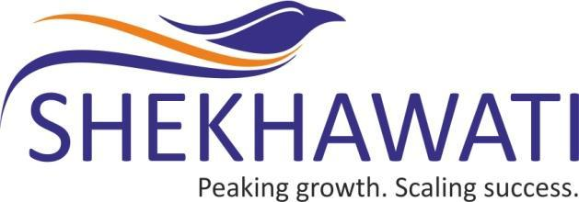

SHEKHAWATI
POLY-YARN
LIMITED
(CIN No.: L17120DN1990PLC000440)

Registered Office : Plot No. 185/1, Naroli Village, Near Kanadi Phatak, Silvassa, D & N.H.- 369230.

Corporate Office : Express Zone, A-Wing, Unit No.1102-1103, 11th Floor, Patel Vatika , Off. Western Express Highway, Malad (East), Mumbai - 400 097
Tel : 022-66940626/022-62360800
Website : www.shekhawatiyarn.com E-mail Id : cs@shekhawatiyarn.com

During the financial year 2022-23, the following familiarization programmes were held by the Company for the Independent Directors and Board of Directors of the Company:

Sr. No. | Subject matter | No. of programmes |  | No. of hours spent by the Independent Directors and Board of Directors
 |  | FY 2022-23 | Cumulative Till date | FY 2022-23 | Cumulative Hours Till date
1 | Review of business and operations and Development of strategies and Future Business Plans | 4 | 17 | 2.0 | 7.5
2 | Awareness about the latest developments in the area such as Corporate Governance framework, financial reporting, industry and Market conditions | 2 | 5 | 2.0 | 3.5
3 | Fulfillment of Directors fiduciary responsibilities | 1 | 7 | 0.5 | 3.5
4 | Participation in Board and Committee meeting and Updating on Rights and responsibilities of Independent Directors in line with the statutory amendments | 2 | 5 | 1.5 | 4.5

